The 2 Sections - Division of Day and Night

Alchemical Sky Model

Cancer to Aquarius – Day – East Section.
Capricorn to Leo – Night – West Section

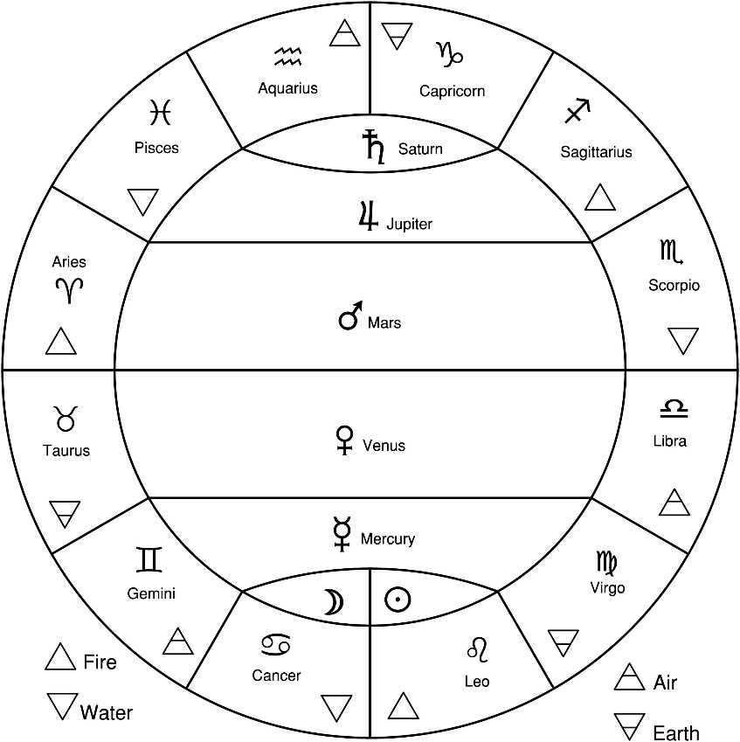

On the next page, note the two figures on top with horns (made large to add emphasis). This is Saturn in Aquarius (left) and Saturn in Capricorn to the right.

Notice the Cancer the Crab on the left.

A scarab/dung beetle is the Old Kingdom Zodiac image of Cancer. In the Hieroglyphic Sign List, It is F1. The glyph means, come into existence, become, happen, and make.

“The god [Khepri] was connected with the scarab beetle, because of the scarab rolls balls of dung across the ground, an act that the Egyptians saw as a symbol of the forces that move the sun across the sky. Khepri was thus a solar deity.” – Wikipedia.

Therefore a connection between Cancer – Leo.

Pronaos Ceiling Layout

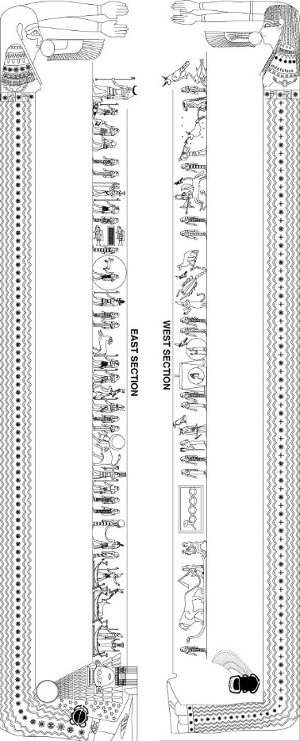

EAST SECTION – Day

Note: The Number refers to the pictures (JPEG files) describing in the text.

In the East Section, the layout of the astrology signs are opposite that actual direction of the constellations. That’s because the east section drawing was flipped and rotated to put the rising sun in the east and setting sun in the west.

3 – Cancer and Birth of the Sun

Cancer, the Crab, tucked in Nut’s legs. The Crab is sitting in a pool of water (green). It is half in the water and half out. Similar to crab in Key 18, the Moon.

Nut is giving birth to the Sun

Small barge with the snake is the 1st day of creation.

Hathor has her own blue-green color - turquoise.

4 - The 3 Barges with Gods

1. Barge: Satis (protector and Nile goddess) and Ankuet (Nile goddess) in the 1st barge.

Sirius and Procyon have a Raised Star.

2. Barge: Sothis Cow – Sirius in the 2nd barge.
- Raises star between horns.

Horus on the papyrus flower – Procyon.
  - Raised star nearby

3. Barge: Sah (Egyptian), Anu (Sumerian), Orion.
- The only figure with 6 raised stars.

The last hour of the night (12th) is turned to watch the Sunrise.
- The One who Sees the perfection in her master.

5 – Gemini

Gemini = Skemet, and Shu

Skemet – Goddess of Moisture. Sekhmet wears a solar disk - female Sun goddess.

Shu – God of Air.

11th Hour: The one who repels demons.
10th Hour: The One who protects his master.

God with Star – Jupiter in Gemini

Planet | Sign | Disability | Triplicity +3 | Term  +2 | Face  +1 | Total
Jupiter | Gemini | Det (-5) | Air | 7 - 13.59º | 1st | +1

Mercury in Gemini – Rulership – Twin Feather Crown

Gemini (Mercury), like Taurus (Venus), shows duality symbolism. Both are morning and evening stars.

Goat-head Staff – North Node Exalted in Gemini

Mercury in Gemini is holding a goat-headed staff (fixed star Capella, the goat star).

Gemini is the only planet that is not holding a “was” staff.

6 - Taurus

Taurus = Fixed Earth and holds up Moon.
- Moon is Exalted in Taurus.
- Eye in Tail = Pleiades?
- Moon = N10 and N11 of Hieroglyphic Sign List.

9th Hour: Mistress of fear
8th Hour: The One whose flame hurts

Two-headed Venus

Human head – Red Crown of Upper Egypt
Bird head – White [Green] Crown of Lower Egypt.

Both Mercury and Venus are only seen in the morning and evening.
- Green Moon Crown

Mercury is no more than 28 degrees from the Sun.
Venus is no more than 48 degrees from the Sun.

Falcon with Crown

The only “planetary bird” in the East Section. Venus is in Taurus.

Except for Libra also ruled by Venus, this is the only section that has the planet depicted twice - maybe. Check out Scorpio section.

Faces or Decans of Taurus
Moon-Mercury – Saturn

Green Baboon (Moon + Mercury)
Brown Oryx = Saturn.

Old Kingdom Zodiac – Dog

Venus in Rulership (+5) and Triplicity by Day (+3) = +8 Venus.

Moon in Exaltation (+4) and Triplicity by Night (+3) = +7 Moon.
- +1 for the 2nd Face of Taurus

Dogs are loving (+8 ♀) animals (+7 ☽ Moon).

7 - Aries

God with Star – Saturn in Aries

Planet | Sign | Disability | Triplicity +3 | Term  +2 |  | Total
Saturn | Aries | Fall (-4) | Fire | 26 - 29.59º |  | +1

Tomcat – Sun in Aries – Exaltation

Lion head wears a male skirt

No one is wearing a crown.

7th Hour: The One who fights for her master.

8 - Pisces

6th Hour: Mistress whose Image is splendid.

Horus with Atef Crown – Jupiter in Pisces

In Pisces, Jupiter dignified by Rulership (+5).

Atef Crown = Night Sign

Osiris in Side Full Moon

Moon is dignified by Mixed Triplicity (+3).

Brown pig = Saturn. Pisces ends the winter signs.
- Horus and the Black Pig

Pisces, the Fish

Green colors are bright in original art.

Square of Pegasus

Symbol of Water N35 in the Hieroglyphic Sign List

Bluewater = celestial water

Square of Pegasus = Sea of Knives?

Horus the Red – Mars

Notice he has a star above his head. He is the only on the three gods with stars that have a name – Horus the Red = Mars.

Mars in Pisces is Triplicity, Term (20 - 25º59”), and 3rd Face.
- +6 Mars which is more dignity than Ruler (Jupiter).

5th Hour: Mistress of Life
4th hour: The One whose prestige is great.

Old Kingdom Zodiac – Crocodile

The Pisces Constellation looks like the wide open mouth of a Crocodile.

+6 Mars is more dignified than Jupiter in Rulership (+5). So it is the stealthy crocodile (+6 Mars) that gets to be the Old Kingdom Zodiac image for Pisces.

9 – Aquarius

Hapi = Nile God. Big belly and breast. – Jupiter imagery.
- Jupiter is Mixed Triplicity in Air Signs.

3rd Hour: The One who drives back evil.
2nd Hour: The One that raises her Master.

- – Aquarius - Capricorn

Brown Headless Daemon

Sun = Face.
- Sun in Determent (-5) in Aquarius.

Sokar – Ominous One

“With the 2nd decan [of Capricorn] there arise… the central part of the Ominous One of the Dodecahoros. With the 3rd Decan there arises the other half of the Throne and the tail of the Big Fish and the Altar and the Headless Daemon holding his own head and the back of the Ominous One of Dodecahoros.” – Teucer of Babylon p. 185.

Brown Oryx

Brown Oryx is a symbol of Saturn and Winter.

Cygnus

Mars is Exalted in Capricorn and dignified by Mixed Triplicity.

Mars is standing on the back of Cygnus the Swan, marking the Winter Solstice.

“And in the 3rd decan [Aquarius] there arises the Big Bird, which is called Cygnus.” –Teucer of Babylon

Horus the Bull

The two bull-headed Saturn’s connect the 2 sections.
- Why is the figure with the most obvious name get hieroglyphs and the other figures get nothing? It not like the artists didn’t have enough room.

WEST SECTION

11 – Capricorn

1st Hour: Mistress of the spheres

Capricorn is painted brown – Earth Sign.

Bull Headed Falcon – Saturn in Capricorn.

12 - The Northern Constellations

2nd Hour: The One that raises her master.

Taweret – Great Bear Constellation

Protective goddess of childbirth and fertility. Taweret = “She who is great.”

Her back is a crocodile tail. – The Big Dipper.

Bootes Constellation – Meskhetyu

Where the cord attaches is the location of the fixed star Arcturus.

Meskhetyu – And instrument used in the opening of the mouth ceremony.

Raised Stars = Northern Crown

The crown is worn by this figure and the Harrow Constellation (Serpent Holder).

F24 – Foreleg = power, strength.
V28 - Twisted Flax = Pisces = ideas associated with time and eternity. See Leo section.
F34 – Heart = Heart, the seat of consciousness.
W11 – Jar Stand = seat, throne.

The picture suggests the rotation of Arcturus around the Pole Star.

13 – Sagittarius – The Hawk (Aquila) - Horus

Horus that Hits His Enemies

Aquila, the Eagle, was the Old Kingdom Zodiac sign for Sagittarius.

3rd Hour: The One that removes evil.

Falcon with unique crown – Jupiter in Sagittarius

Fixed star Vega is 2nd brightest in North Sky (Arcturus is brightest).

The Babylonians called the fixed star Vega the Queen of Life. Vega means, “falling eagle.”

Sagittarius the Archer

Sagittarius has a raised scorpion tail.
- South Node (Dragon’s Tail) is exalted in Sagittarius.
- Sagittarius wears Atef crown of the other/under/neither world.
- Lion head = Sun is dignified by Day in Triplicity.

Cargo Boat – Lower culmination (opposition) with Sagittarius

4th Hour: The One whose prestige is great.

14 – Scorpio

5th Hour: Mistress of Life.

Wolf and Plow – Babylonian Constellation

From the round zodiac of Dendarah hanging the Louvre, the Wolf and Plough are a circumpolar constellation. North Star (Thuban) located on the plow handle. Thuban because it’s a Babylonian Constellation.

Falcon with Moon Crown – Mars in Scorpio

Scorpio the Scorpion - all color is lost.

Green Hippo Goddess with Moon Crown

Scorpio = Fixed Water. Hold holds up incense offering.

Both Scorpio and Scorpion woman have tails and arms outstretched in the same direction. They may be the same constellation.

Or….

Two figures in the Scorpio section wear a Moon Crown. The Falcon and Hippos Goddess.

Are they both Mars in Scorpio?

Old Kingdom Zodiac – A Bull

+11 Mars – The Raging Bull

When Sun in Taurus, you can see the constellation because the sun is too bright. When Sun in Scorpio, the opposite sign, Taurus the Bull is visible at night.

Hathor (Taurus) was a raging bull and almost destroyed humanity.

Gilgamesh defeated the Bull of Heaven.

Planet | Sign | Rulership | Triplicity | Term  0º - 5º59” | 1st Face | Total
Mars | Scorpio | +5 | +3 | +2 | +1 | +11

8th Hour: [The One whose image is splendid.] – Original image damaged. Seville reconstructed Name.

15 – Libra

7th Hour: [The Uranus who fights] for his master.

Falcon with Moon Crown – Venus in Rulership.

Note that Venus is shown twice just like in the Taurus panel.

Crowned Woman inside Full Moon-Venus in Libra

Moon is dignified by Face (+1) in the 1st decan of Libra.

The figure carrying a staff is badly damaged.

The Ram/Goat Staff

“The ram deity of Mendes was described by Herodotus in his History as being represented with the head and fleece of a goat: “...whereas anyone with a sanctuary of Mendes or who comes from the province of Mendes, will have nothing to do with (sacrificing) goats, but uses sheep as his sacrificial animals...” Wikipedia.

Ram = Jupiter. Mixed Triplicity. 3rd Face.

Goat = Saturn. Exaltation. 2nd Face.

The Book of the Heavenly Cow describes the Ram of Mendes as being the Ba (Soul) of Osiris. Part of the Divine Tribunal to judge (Saturn in Libra) between Horus and Seth.

Libra the Scales

The conception of Horus is inside a full Moon.

Two full moons right next to each other.

8th Hour: The One whose flame hurts.

16 – Virgo

9th Hour: Mistress of Fear

Big Falcon with Green baboon head (Thoth) – Mercury in Virgo
- Virgo is the biggest bird and raised so high that his head touches the top.
- Lower band carved around the top of the head.

The Harrow Constellation – Babylonian Constellation

Brown colors
Looks like the Serpent Holder.

Virgo the Virgin with Staff of Wheat

Brown staff. Virgo is an Earth sign.

Wheat seeds = children = Mercury exaltation

10th Hour: The one who protected her master.

17 – Leo

The Leo section is 1/3 of the West Section. Biggest section.

11th Hour: The One that rejects demons.

Serpent inside Rectangle

In Ancient Egypt has a Sun Goddess. And the symbol of the goddess is a hooded cobra.
- I12 in the Hieroglyphic Sign List.

A hooded cobra, in the shape of a twisted flax or rope.
Flax is V28 in the Hieroglyphic Sign List.

The other twisted flax (V28) is holding the Foreleg (F23) to the Heart (F34) in the Northern Stars chapter.

Ninmah – Babylonian Constellation

“…in the first decan there arises a goddess seated upon a throne and holding a child, whom some say is the goddess Isis in the atrium nursing Horus.” – The 12 Signs from Teucer of Babylon, Virgo chapter.

The Raven Constellation

The Raven sits on the Hydra, the water serpent. Rhetorius the Egyptian list the Raven constellation under the Virgo decans.

Frond of Erua – Babylonian Constellation

The women with a whip is standing on the Hydra. She holds the lion’s tail.

Gavin White has this to say:

“A late Babylonian text describes here a goddess holding a frond of a date palm in her right hand, but a Neo-Assyrian text describes her holding a whip which ‘points towards the Lion’s tail.’”

Leo the Lion

Leo is a Fire sign, and much of the red color in the original color remains.

Leo is ruled by the Sun. In Leo, the King is on his Throne of Rulership.
The Hydra Constellation

Old Kingdom Zodiac – The Donkey – Saturn In Leo

Planet | Sign | Disability | Triplicity +3 | Term  +2 | Face  +1 | Total
Saturn | Aries | Fall (-4) | Fire | 26 - 29.59º |  | +1

One of the symbols of Saturn is an ass or donkey.

One of the symbols of Leo is the King.

“Then, high riding, ass-borne, came one who was to reveal the Light to men. Praises to the Lord of Light and Life for Hurmanetar the Light-bringer.” – Book of Gleaning, Chapter 6:2, p. 49.

“Jesus found a young donkey and rode on it, fulfilling the prophecy that said: “Do not be afraid, Daughter Zion; see, your king is coming, seated on a donkey’s colt.” – John 12:14 & 15.

12th Hour: The One who sees the perfection of her master.

18 - Scarab Beetle – Kheper

The Scarab Beetle is L1 in the Hieroglyphic Sign list. It means, come into existence, become, happen, make. When the hieroglyphic is used as a plural, it means, form, shape, upbringing, stages of growth. As a symbol, it is the rising Sun.

Old Kingdom Zodiac – Cancer – Scarab Beetle

This detail directs our attention back to the East Section, the Crab tucked between Nut’s legs and the rising sun.

Date of Zodiac of Dendarah

Based on the hieroglyphs used, the Pronaos ceiling of the Dendarah temple was painted during the Ptolemaic Era (323 – 30 BCE).

Astrology - Essential Dignities

Rulership (+5) Term (+2)
Exaltation (+4) Face (+1)
Triplicity (+3)

There is evidence for the use of Rulership and Exaltation in Sumerian texts (1800 B.C.E.). Triplicity, Term, and Face are listed in later texts (100 - 400 C.E). The Zodiac of Dendarah pushes this date of the use of the 3 other essential dignities to the Ptolemaic Era.

Astrological Signs vs. Constellations

Astrological Constellations are used to tell time.
Astrological Signs are used for telling stories. The stores are told by the Essential Dignities and Debilities.

The Colors on the Drawing

The colors are 2,000 years old, and most of it is gone.

Fire  Red | Water  Pale Green | Earth  Brown | Air  Blue
Aries, Leo,  Sagittarius | Cancer, Scorpio,  Pisces | Taurus, Virgo, Capricorn | Gemini, Libra,  Aquarius
Fire Signs | Water Signs | Earth Signs | Air Signs
The goose (highlights)  in Capricorn | Osiris | The Harrow | Nuts Body  Isis
 | 2 Baboons | The Pig | Headdress of the gods
 |  | The 2 Oryx | everywhere

Hathor has a unique bluish green color.

The background of the gods is a light blue (sky blue). The headdress of the gods are dark blue. Only one color of blue is used because dark blue does not show up well against black.

Introduction to the Tetrabiblos, p.40.

Saturn rules beaver-colored [dark brown] dyeing; Jupiter, pale blue [bluish grey] and inclining a bit towards white; Mars, fiery – really flame-colored; the Sun, golden yellow; Venus-white colored; Mercury, dark blue; the Moon, pale green.

…And it is of the nocturnal sect. Light green in color… Rhetorius The Egyptian, p. 204.

Old Kingdom Zodiac

 | Zodiac
 | Modern | Old Kingdom | Comments
1 | Aries | Tom Cat | Sun is Exalted in Aries
2 | Taurus | Dog | Venus & Moon in Taurus
3 | Gemini | Snake | North Node – Exalted in Gemini
4 | Cancer | Scarab | Kheper – Becoming – new day & birth
5 | Leo | Donkey | Saturn in Leo
6 | Virgo | Lion | Moon in Virgo by Night
7 | Libra | Goat | Saturn in Libra by Day
8 | Scorpio | Bull | Mars in Scorpio – 1st decan
9 | Sagittarius | Hawk | Horus
10 | Capricorn | Baboon | Thoth – Moon in Capricorn by Night
11 | Aquarius | Ibis | Thoth – Mercury in Aquarius by Night
12 | Pisces | Crocodile | Mars in Pisces.

Old Kingdom = Dodecahoros

Observations

1. Raised vs. painted stars on the drawing – show pic.

2. Planets in East Section (Day) are anthropomorphic and carry “was” staffs.

3. Planets in the West Section (Night) are birds.

4. East and West Section – planets in rulership wear crowns.

5. Raised stars indicate planets, gods, and goddesses.

6. Aries, Virgo and Leo figures do not wear crowns.

7. The two symbols of Cancer (Crab and Scarab Beetle) and two figures of Saturn (anthropomorphic Bull & bull-headed bird) connect the two sections.

9. Two birds in East Section – Horus on the papyrus flower and Venus in Taurus.

10. The White Crowns of Egypt are green (except Sah – his is blue).

11. Boats have blue to represent celestial boats.

12. East Section 3 planets/gods have raised stars overhead, Aries, Taurus, and Pisces (Triplicity, Term, and Face).

13. The Different Days and Nights

A. The Day is East and Night is West

- East = Day = Cancer to Aquarius
- West = Night Capricorn to Leo

B. Day and Night by Crowns.

- Aries to Virgo – Day.
- Libra to Pisces – Night. Jupiter in Pisces was the Atef crown of the otherworld.

